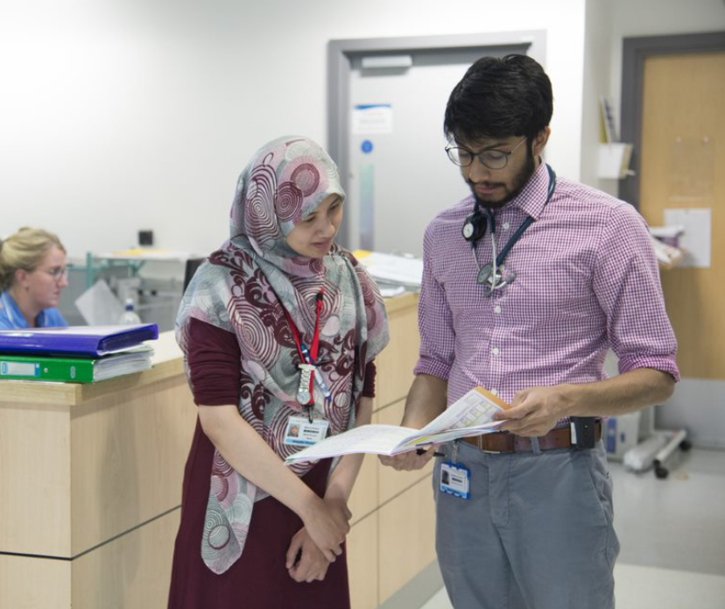
.

Readiness for Advanced Practice 2022/23
Primary Care Training Hub (PCTH)

HEE South West Faculty of Advancing Practice

Is my PCTH ready to implement and support Advanced Practice?

- Advanced Practice (AP)
- Primary Care Training Hub (PCTH)

Many PCTHs and employers have requested support with the development of advanced practice roles. This Readiness for AP Checklist has been developed for PCTH to self-assess their readiness for advanced practice and to identify possible next steps.

The Checklist

The checklist is based on the key principles of the Multi-professional framework for Advanced Clinical Practice in England and should be carried out by the AP lead (or other senior education lead responsible for AP) at PCTH level. PCTHs can rate their extent of readiness using a (B)RAG rating:

 | Black | No evidence this domain is embedded
 | Red | Some evidence this domain is embedded in a few parts of the organisation
 | Amber | Evidence this domain is embedded in most parts of the organisation
 | Green | Fully embedded in organisation

An action plan with SMART objectives can be developed by the PCTH in response to their self-assessed readiness. This should be co-ordinated by the AP lead (or other senior education lead) in conjunction with colleagues and the executive sponsor.

This self-assessment is a tool available to help PCTHs establish their readiness across their system and will help to inform decisions about future funding to support AP.

The information gathered will be collated in a way to help Health Education England (HEE) identify areas in which we can better support both systems and employers across the South-West region to develop AP. Please also refer to the HEE ACP Toolkit when completing the checklist.

The link to AP frameworks can be found here: https://www.hee.nhs.uk/our-work/advanced-practice/credentials

Should you need any support in completing this checklist or have any questions please email our Workforce Transformation Lead – Lou Buckle on lou.buckle@hee.nhs.net

Advanced Practice Readiness Checklist

Name of PCTH:
Completed by: | Executive sponsor:
Name & Job title:  Date: | Name & Job title:  Date:

Readiness domain | Demonstrated by… | (B)RAG rating | Explanation of rating / proposed action
Awareness and commitment
Nominated PCTH AP lead role(s) in place | Named AP lead(s) in place and funded
There is a plan for AP communication and engagement led by AP lead across all eligible non-medical professions | Plan for communication and engagement to support AP Steering Group and forum(s) in place
Commitment to work strategically with HEE and HEIs (Higher Education Institutions) to ensure robust and appropriate commissioning of AP training | Regular strategic planning meetings with HEE/HEIs
Leadership of collective discussions with Primary Care Networks (PCNs) about their AP plans encouraging the sharing of knowledge and joint working where possible | Joint working and collective discussions held
Commitment to regularly (minimum annually) review readiness for AP as an PCTH | AP Readiness Checklist, supporting action plan
Strategic workforce case for advanced practice
Agreement at PCTH and/or ICS (Integrated Care System) level on recommended AP job descriptions, job titles and banding | System AP job descriptions
ICS AP Steering Group has oversight of impact of AP roles including those in primary care | Provider service and patient evaluations
Understanding current advanced practice workforce
Understanding of current and planned AP roles across PCTH | AP workforce data
Enablers for Advanced Practice
Consideration given to pooled use of apprenticeship levy to support development of AP roles in PCNs | Conversations held  Apprenticeship levy process outlined
Identify AP leads within PCNs to establish local training needs and AP development pathways | Career development and training pathway documents
Advanced practice supervision
Consideration given to PCTH approach and support for educational and clinical supervision | Supervision plans  Local community of practices
Identify network of educational supervisors within PCTH | Directory of supervisors within PCTH
Provide resources and support for non-clinical aspects of AP - education, leadership & research | Example job plans for APs in primary care

Appendix 1

Which Professions Can Apply for Advanced Practice Roles?
Advanced practice can be undertaken by regulated health professionals. This list is not exhaustive and is likely to grow as Advanced Practice roles, frameworks and credentials progress.

These are the professional groups that are eligible for the 2022/23 Annual Demand Scoping Survey, which employers will submit to HEE Faculty of Advancing Practice:

- Arts Therapists (Music/Drama/Art)
- Biomedical Scientists
- Chiropodists/Podiatrists
- Clinical Scientists
- Dieticians
- Hearing Aid Dispensers
- Midwives
- Nurses
- Occupational Therapists
- Operating Department Practitioners
- Orthoptists
- Paramedics
- Pharmacists
- Physiotherapists
- Practitioner Psychologists
- Prosthetists/Orthotists
- Radiographers/Sonographers/Mammographers
- Speech and Language Therapists

